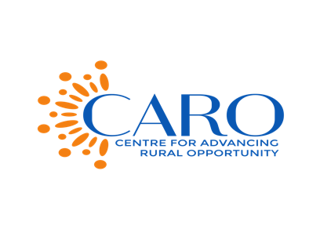

CENTRE FOR ADVANCING RURAL OPPORTUNITY (CARO GHANA)
GLOBAL HAND WASHING DAY 2023

Each year on October 15, globally the world celebrates Global Hand Washing Day to advocate and raise awareness about the importance of handwashing with soap and water. It is one of the basic ways by which we can prevent sicknesses and the spread of germs. Keeping hands clean can prevent 1 in 3 diarrhea illnesses and 1 in 5 respiratory infections, such as the common Cold or Flu.

The theme for this year; “Clean Hands are Within Reach” calls for ‘strong leadership and collective efforts’ to close gaps and access to hand hygiene products. Handwashing with soap and water is simple and inexpensive and it can significantly reduce the number of young children who get sick of diarrhea between 23%-40% (CDC,2023)

Access to basic hygiene services in Ghana is 42% with 22% of the households having no hand washing facilities. An assessment by UNICEF indicates that 54% of schools in Ghana have access to basic services with high level of services in urban schools (65%) than for rural schools (45%). This implies that almost half of the schools in rural areas lack access to basic hygiene services (46%).

I call on government, to increase investment and resources in strengthening WASH systems at the district and community level and facilitate coordinated actions to actively work towards universal hand hygiene. I also entreat you to continue practicing hand washing with soap in your school and at home. Many germs can make people sick are spread when we don’t wash our hands with soap and clean, running water. Therefore it is important to always wash our hands especially at key times such as after using the bathroom, when preparing food, before eating and after coughing, sneezing or blowing your nose.

As part of activities today, to mark this year’s global handwashing day in the Upper West Region, the Centre for Advancing Rural Opportunity (CARO GHANA) in partnership with the Environmental Health Department of the Assembly is organizing a hand hygiene sensitization durbar, a radio discussion and quiz competition on Hand Hygiene in Kuoli Primary and JHS in Lawra to commemorate this year’s #GHD2023.
On behalf of CARO GHANA, I wish to donate these hand washing materials (veronica buckets) and assorted items including soap and books to support the school.

Thank you All and let’s keep washing our hands!!!

ABOUT CARO GHANA
The Centre for Advancing Rural Opportunity is a nonprofit organization in the Upper West Region working to empower and promote the well-being of people in society especially vulnerable groups for a resilient and sustained community development. We work in the WASH sub-sector, Health, Governance, Youth Development and Women Empowerment.

Tel: 0547840902 / 0507121220
Email: caroghana@gmail.com
Website: www.caroghana.org

