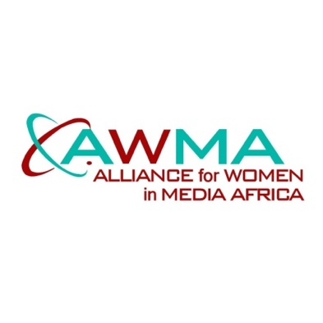
AWMA CONGRATULATES PORTIA GABOR-GJA JOUNALIST OF THE YEAR AND ALL FEMALE WINNERS AT 26th GHANA JOURNALISTS AWARDS.

Portia Gabor, Journalist of the Year 2021, Member AWMA Steering Committee.
14/11/22- The Alliance for Women in Media (AWMA) notes with pride, the crowning of its Steering Committee member, Mrs. Portia Gabor as the Journalist of the Year 2021 during the 26th Ghana Journalists Association (GJA) Awards.
Indeed, Portia Gabor has shown consistency over the past decade, picking up several awards for her various special reports in the areas of Health, Disability and Vulnerabilities. She has also shown a high sense of professionalism, dedication to duty and passion for what she does and it is no surprise those efforts have culminated in being rewarded with the highest journalism professional award in Ghana. Ayekoo!
She has proved that, despite all the threats, risks, challenges and tears this profession poses to practitioners, women are also willing and determined to make their mark.
The Steering Committee of AWMA, of which Portia Gabor is a member, and the general membership, share in her moment of pride and heartily congratulate her for this great and significant feat.
Portia Gabor in reaction to this great honour, has paid glowing tribute to the pacesetters who broke the glass ceiling and on whose shoulders the next generation of young female journalists ride on to dream bigger dreams and to achieve even greater honours.
AWMA knows that Portia Gabor will not only continue to work hard to churn out impactful stories, but is also committed to mentoring, training and motivating young women in the profession.
AWMA will also like to congratulate all the ladies who won various category awards on the night: Peggy Ama Donkor (GTV), Mavies Ofei Akyeampong (GTV), Juliet Bawuah (TV3), Francisca Enchil (Joy Prime/Freelance), Benedicta A. Gyima (Ghanaian Times) and Beatrice Senaju(GBC). You have made us all proud and shown that we indeed have the women.

Signed:
Shamima Muslim
Convenor, AWMA.

