
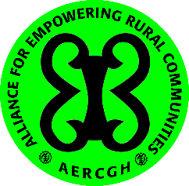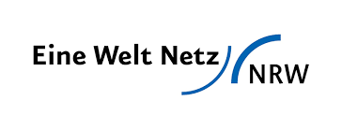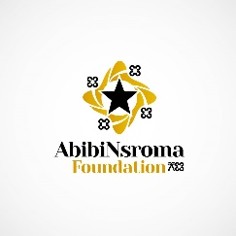
PRESS RELEASE: AERC GHANA AND PARTNERS COMMEMORATES WORLD ENVIRONMENTAL DAY 2020
“LETS PRIORITIZE NATURE BASED SOLUTIONS AS A NATION”
Today marks World Environment Day 2020. It is another wake up call to the nation of Ghana and the nations of this world to safeguard the environment, protect biodiversity and preserve the planet for the future generations. Every year the World Environment Day inspires thousands of people in Ghana and millions all over the world to take action for the sake of the planet by contributing to different events and projects. The United Nations Environment Programme (UNEP) has chosen “Time for Nature” as the theme for this year’s World Environment Day celebration and has been adopted by all across the world. This year’s theme is with the emphasis on its role in providing the necessary structures that supports life on earth and human development. This focus also is anticipated to provide prospects for driving the energy and public awareness of nature as a key aspect in addressing climate change.
Alliance for Empowering Rural Communities (AERC) and its partners— Eine Welt Netz NRW, AbibiNsroma Foundation (ANF), African Youth Initiative on Climate Change (AYICC) and the Coalition of NGOs in Tema (CONGOT) acknowledge that nature-based solutions have the potential to offset the stresses posed by climate change, urbanisation and its associated proliferations in the numbers and size of communities impacting the ecosystem with stresses which include loss and degradation of natural habitats, soil sealing and the densification of built-up areas, which pose further major challenges to ecosystem functionality, the provision of environmental services and human well-being in urban and rural communities.
Nature-based solutions involve actions that work with and enhance nature so as to help people adapt to climate change and disasters. Nature-based solutions can help make communities more resilient to the adverse impacts of climate change and significantly reduce greenhouse gas emissions, including emissions from agriculture, deforestation and forest degradation, while also benefiting human well-being and biodiversity. These solutions can range from simply protecting natural areas to increasing the genetic diversity of trees to increase forest resilience, all the way to planting new ecosystems to make cities greener and clean up polluted areas.
While it’s merely one of numerous approaches for adapting to climate change, we maintain that restoring ecosystems ought to be given due consideration on the national platform of climate action and could be a game-changer in our climate adaptation.
As environment and climate change allies, we recognize that climate change is a big threat to nature and the survival of the human race. Therefore, we commit to advocating for and taking action towards climate-resilient communities and nation as a whole. In lieu of that, we advocate for communities to consider the biodiversity of their areas as the core of community resource management initiatives.
Biodiversity is the variation of Earth’s terrestrial, freshwater, and marine species, as well as their habitats. Biodiversity is vital to the survival of all life on earth and is also the foundation for the goods and services of the environment that allow human civilisations to succeed. Biodiversity provides us with food, water and resources as well as services such as climate control, pollination, flood mitigation and cycling of nutrients.
The theme for this year’s celebration demonstrates that Biodiversity remains the solution to a number of sustainable development challenges that we all face. From nature-based solutions to climate, to food and water security, and sustainable livelihoods, biodiversity remains the basis for a sustainable future.
As Alliance for Empowering Rural Communities and partners, we pledge our contribution to the protection of nature, awareness raising and support to communities in managing their natural resources as we commemorate this year’s World Environment day. We seek to educate the general public on the need for conservation and adapting ecovillage strategies as models for sustainable development. We aim to be active role models in reducing our individual and collective climate impact in our personal and professional lives. We aim to foster meaningful youth participation with local, regional and international climate action and community natural resource governance.
We strongly urge the Ministry of Environment, Science, Technology and Innovation (MESTI), the Forestry Commission and the EPA to as a matter of fact give more attention to nature-based solutions as they can foster and simplify actions in urban landscapes by taking into account the services provided by nature.

We particularly encourage the Ministry of Lands and Natural Resources (MLNR) to take pragmatic steps in ensuring that communities are well equipped in nature-based solutions as part managing their natural resources as nature-based solutions will render benefits irrespective whether or not the climate change impacts and/or extreme events are realized. This is imperative given the scarcity of resources and conflicting choices.
We celebrate the World Environment Day 2020 to illustrate our standpoint and cause for nature. We are strongminded to fight for our nature, planet and ecosystem.

By
Richard Matey
Convenor
Alliance for Empowering Rural Communities (AERC)
www.aercgh.org
matey.richard@aiesec.net

